05. Snort Rule Structure

1. Introduction
Snort rules are instructions used by Snort to identify suspicious or malicious network traffic.
They tell Snort which packets to monitor and when to generate alerts.

2. Definition
A Snort rule is a set of conditions that defines which network packets should match a particular activity and what action Snort should perform.

3. Basic Snort Rule Structure
Example:
alert tcp any any -> any 80
(msg:"HTTP Traffic Detected"; sid:1000001; rev:1;)

A Snort rule has two main parts:
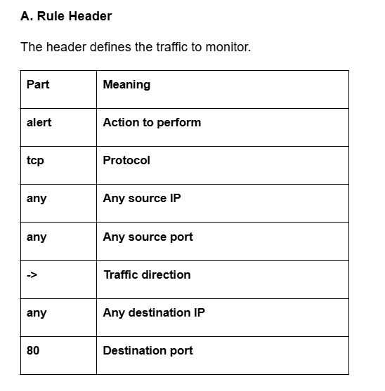
B. Rule Options
Options define additional conditions and alert details.
Example:
msg:"HTTP Traffic Detected";
sid:1000001;
rev:1;

4. Important Snort Rule Options
Option | Meaning | Purpose
msg | Message | Defines alert message
sid | Signature ID | Unique rule identification
rev | Revision | Rule version
flags | TCP Flags | Matches TCP flags
flow | Traffic Flow | Defines packet direction or state
threshold | Alert Threshold | Controls alert frequency
classtype | Classification | Identifies attack category

5. Important Snort Actions
Action | Meaning
alert | Generate an alert
log | Log matching packets
pass | Ignore matching packets
drop | Drop matching packets in inline mode
reject | Block and send a rejection response in supported inline configurations

6. How Snort Rules Work
- Snort captures network packets.
- It checks the packet protocol.
- It checks source and destination IP.
- It checks ports and other conditions.
- It compares the packet with the rule.
- If the conditions match, it performs the configured action.

7. Real-World Example
Rule:
alert icmp any any -> $HOME_NET any
(msg:"ICMP Ping Detected"; sid:1000001; rev:1;)

Explanation:
- alert – Generate an alert.
- icmp – Monitor ICMP traffic.
- any any – Any source IP and port.
- $HOME_NET – Your protected network.
- msg – Display alert message.
- sid – Unique rule ID.
- rev – Rule revision.
When someone sends a matching ICMP ping to your protected network, Snort generates an alert.

8. Conclusion
Snort rules help identify suspicious network traffic. Understanding rule headers and options is important for creating custom detection rules.

